**MINI PROJECT**

**DMX5403**

**CONTROL SYSTEM ENGINEERING**

NAME : W.W.B.U. SALWATHURA PERERA

REG NO : 117150292

DUE DATE : 2021-12-04

**Registration number-117150292**

**first digit-1 Measurement Quantity-Liquid Flow rate**

**Q1)** Combine the orifice plate to the pipe and get the measurement with using a pressure difference put the pressure force to the Diaphragm, with using that force and get the flow rate of the pipe.

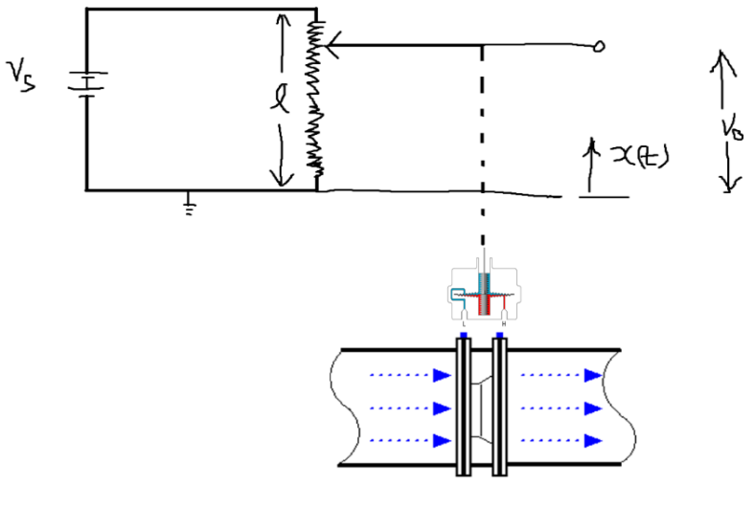

Diaphragm

Orifice plate

pressure

Force

Q-flow rate

Cd-discharge coefficient

Assumption:

Pressure will be small hence assume

flow rate as rate of change pressure :

Transducer

**Input**-get pressure difference with using diaphragm connect to the potentiometer wiper.

**Output**- With using potentiometer change of its resistance due to the pressure difference get the voltage output.

voltage

Pressure difference

**Transducer**

**Q2)**

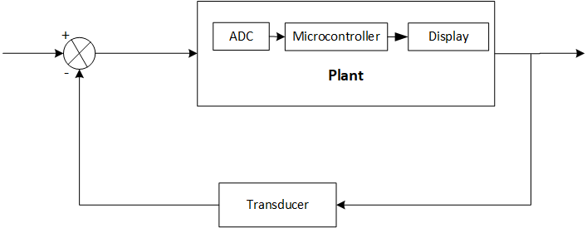

* **Transducer**- Get the pressure difference value and convert it to voltage

.

* **Plant**- Analog signal comes to the Analog to Digital Converter (ADC) and it converts to digital signal that signal gives to the Microcontroller with using the microcontroller it gives the signal to display output of the flow rate value.

**Q3)**

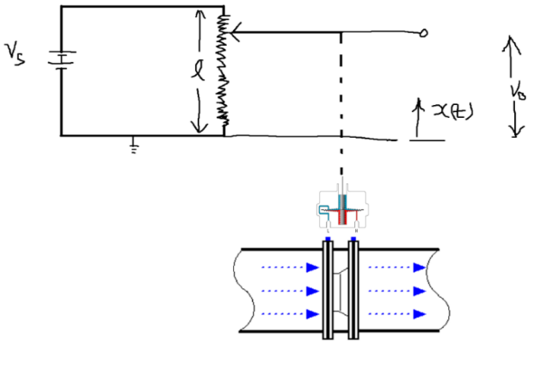**Transfer function of transducer**

K-wiper constant

Vs-source voltage

Rp- total resistance

L-total length of translation

X(t)-displacement of the wiper

Vout(t)-output voltage

Assumption:

get as a flow rate:

* only water will flow inside the pipe
* no affect from the temperature because it built afford to the temperature.
* No any signal delays.

let’s derive the equation for the output voltage,

Therefore,

Equation relation

(because of pressure, it causes the force to the wiper)

With force assume the equation

Hence substitute to the equation

Using Laplace transformation

**Assumption: these values are using for design the transducer**

L=0.01m

Then the transfer function is,

According to the orifice meter equation

Above equation we know

assume

Assumption:

Where U is a constant

Let assume system coefficient as this values,

**Transfer function of plant**

Consider the plant it has elements ADC, Microcontroller and Display, then considering the all the elements one by one we assume transfer function for plant.

**+**

R(s)

C(s)

**-**

C(s)

R(s)

R(s)

C(s)

Then the characteristic equation has 3rd order,

**Q4)** Now consider the transfer function,

and its characteristic equation,

Using Matlab consider the

* **The Routh-Hurwitz criteria**

Reference : <https://www.mathworks.com/matlabcentral/fileexchange/25956-routh-hurwitz-stability-test>

***Result of Routh-Hurwitz criteria***

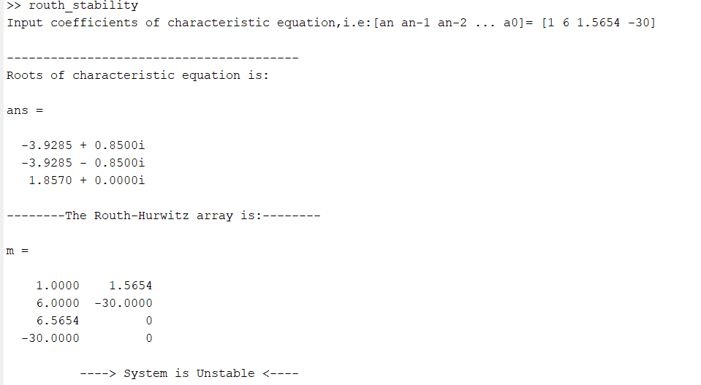

Why Choose: -

when consider the characteristic equation of the transfer function this criterion can easily find out the system is stable or unstable condition using the first column array because if there are no sign changes in the first column, all positive and all roots lie in the left half s-plane hence system is stable, but first column has negative sign then system is unstable.

* **Root locus**

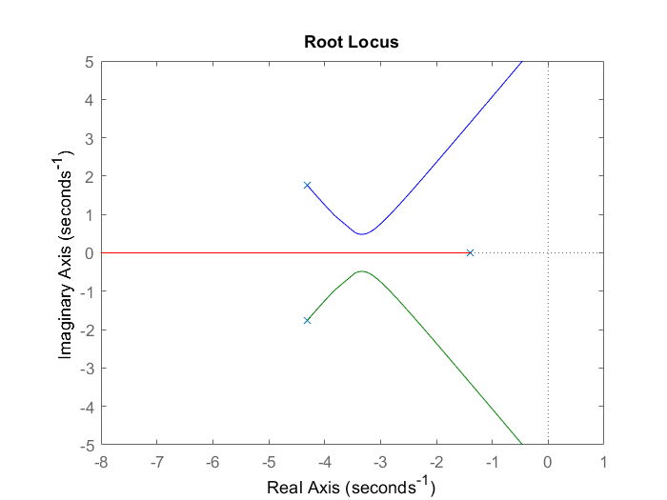



Why choose:

Using root locus easily observe the poles and zeros and get the idea about system stability using root locus. This system is stable because all the poles are in the left half plane.

* **Bode analysis**

Consider of transfer function characteristic equations**,**



***Result of bode******analysis***

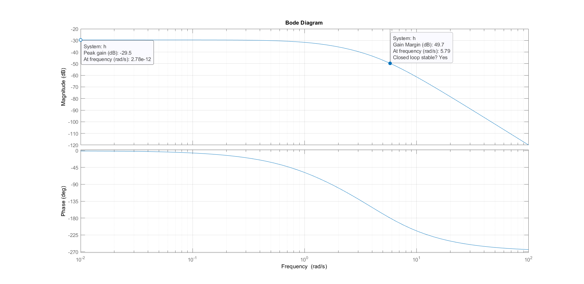

Why choose:

Compare with the Routh-Hurwitz criteria bode plot can get details using frequency and phase plots, easily can identify the gain margin and phase margin of the transfer function, which we can decide the system stability.

**Q5)**

When consider this system characteristic equation, it has 3 poles and according to the bode plot its gain margin is 49.7dB and phase margin infinite when considering the frequency analysis but basically as far as concern real system in the frequency it sometimes cannot be happened in the system. It will need to be increased the system stability. In the frequency response, gain cross over frequency is less than the phase cross over frequency we can get really increase stability of the system.

Consider the step response of whole transfer function it has rise time, settling time and steady state time but here under damped condition because poles have conjugate but here system need to be maintained peak overshoot time with its settling time of the system.

Settling time= 10 sec

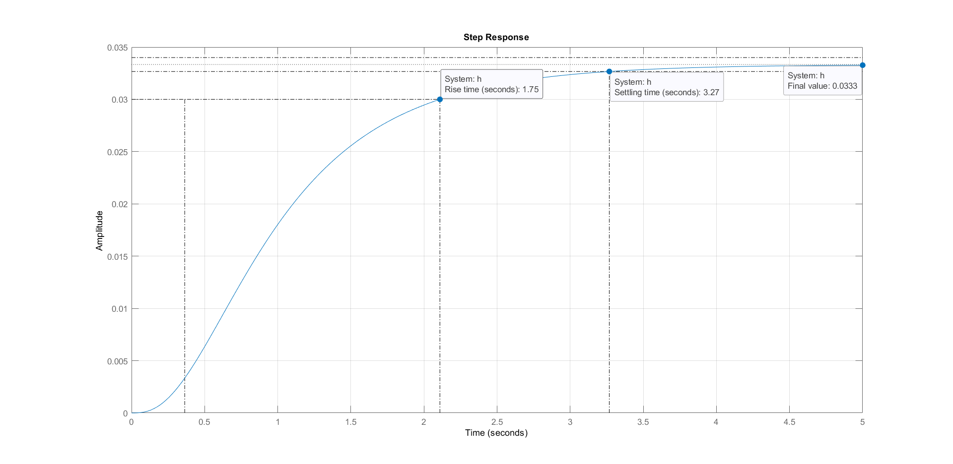



**Q6)**



**+**

Propertional controller

**-**

Transducer

R(s)

C(s)

**+**

**-**

Negative feedback transfer function,

According to desire values, Settling time= 10sec

Using coefficient,

**(2),**

According to the transfer function

